Definition:
Module 4
SPUR GEAR & GEAR TRAINS

Gears whose axes are parallel and whose teeth are parallel to the central line of the gear are called spur gears, used to transmitting motion between two parallel shafts.

Terminologies:
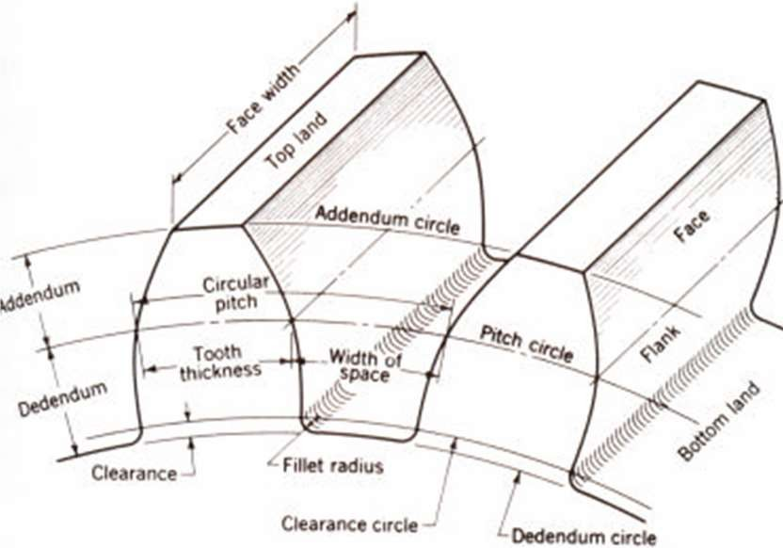
Pitch cylinder: Pitch cylinder of a pair of gears in mesh are imaginary friction cylinders, which by pure rolling together, transmit the same motion as the pair of the gears.
Pitch circle: An imaginary circle which passes through the pitch point having its centre at the axis of the gear, upon which all calculations are made.
Pitch diameter (d): The pitch diameter “d” is the diameter of the pitch circle.
Pitch surface: Surface of the pitch cylinder is known as Pitch Surface.
Pitch point (p): The point of contact of two mating gears on the pitch circle is known as pitch point.
Line of centers: A line through the centre of rotation of a pair of mating gears is the line of centres.
Pinion: The smallest and usually the driving gear of a pair of mated gears.
Rack: It is a part of gear wheel of infinite diameter.
Circular pitch (pc): It the distance measured along the circumference of the pitch circle from a point on one tooth to a corresponding point on the adjacent tooth. Thus, circular pitch is sum of the tooth thickness and width of space.
Z
c
p = m = d

Where, pc = circular pitch, d = pitch circle diameter, Z = number of teeth, m = module
Pitch angle (γ): The angle subtended by the circular pitch at the centre of the pitch circle is

known as the pitch angle.
Diametric pitch (pd): It the number of teeth per unit length of the pitch circle diameter in inches. Limitation of it is that, it is not in terms of units of length but, but in terms of teeth per unit length.
= Z d
d
p

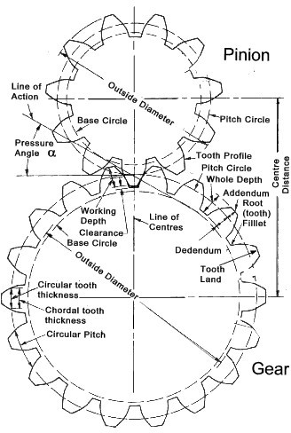
Where, pd = circular pitch, d = pitch circle diameter, Z = number of teeth

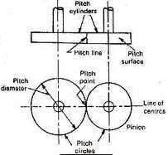

Module (m): It is the ratio of the pitch diameter in “mm” to the number of teeth.
m = d
Z
Where, m = module, d = pitch circle diameter, Z = number of teeth
Gear ratio (G): It is the number of teeth on gears to that on pinion.
G = T or Z 2 or T2 t Z1 T1
Where, G = gear ratio, T or Z2 or T2 = number of teeth on follower (driven gear), t or Z1 or T1 = number of teeth on driver (pinion)
Velocity ratio (VR): It is the angular velocity of the follower to the angular velocity of the driven gear.
1 N1 d 2 T2
VR = 2 = N 2 = d1 = T1

Note: ω = angular velocity = 2πN (rad/sec)
πd1N1 = πd2N2
Addendum: It is the radial height of a tooth above the pitch circle. Its standard value is one module.
Dedenddum: It is the radial height of a tooth below the pitch circle. Its standard value is 1.157 modules.
Addendum circle: It is the circle passing through the tips of the teeth.
Addendum circle diameter = d+2m
Dedenddum (root) circle: It is the circle passing through the root of the teeth.
Dedenddum circle diameter = d-(2×1.157m)
Clearance: Radial difference between the addendum and dedenddum of a tooth.
Clearance = 1.157m – m = 0.157m
Full depth of teeth: It is the radial depth of the tooth space.
Full depth = addendum + dedenddum
Working depth of teeth: The maximum depth to which a tooth penetrates into the tooth space of the mating gears is the working depth of the teeth.
Working depth = sum of the addendum of the two gears.
Space width: It is the width of the tooth space measured along the pitch circle.
Tooth thickness: The thickness of the tool parallel to the tooth measured along the pitch circle
Face width: It is the length of the tooth measured parallel to the gear axis.
Top land: It is the top surface of the tooth.
Bottom land: It is the surface of the bottom of the tooth between the adjacent fillets.
Face: Tooth surface between the pitch circle and top land.
Flank: Tooth surface between the pitch circle and bottom land including fillet.
Fillet: It is the curved portion of the tooth flank at the root circle.

Line of action (pressure line): The force, which the driving tooth exerts on the driven tooth, is along a line from the pitch point to the point of contact of the two teeth. This line is also the common normal at the point of contact of mating gears and is also known as the line of action. Pressure angle (): The angle between the pressure line and the common tangent to the pitch circle is known as the Pressure angle.
Angle of action (): It is the angle turned by the gear from the beginning of the engagement to the end of the engagement of a pair of teeth, i.e. the angle turned by the arcs of contact of respective gear wheels. Similarly angle of approach (α) and angle of recess (β) can be defined.
∂ = α + β
Base circle: It is an imaginary circle used in involute gearing to generate the involutes that form the tooth profile. Base circle radius = rb = r cos φ

Law of gearing:
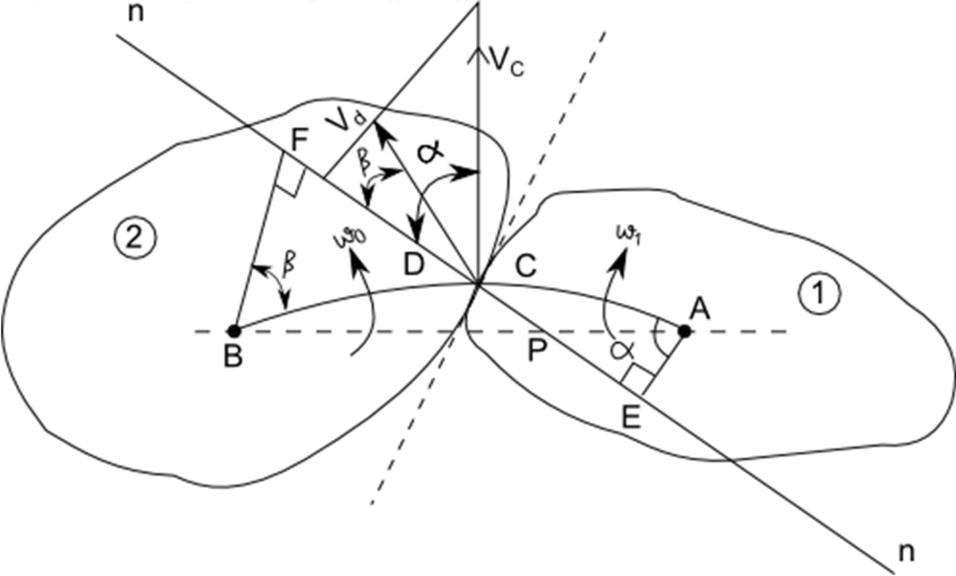
In order to have a constant angular velocity ratio, for all positions of wheels, the pitch point must be the fixed point for the two wheels or the common normal at the point of contact of the two mating teeth must pass through the pitch point.

A point C on the tooth profile of gear 1 is in contact with a point D on the tooth profile of gear
2. The two curves in contact at point C or D must have a common normal at the point. Let it be
n - n.
Let, ω1 = instantaneous angular velocity of gear 1 (clockwise)
ω2 = instantaneous angular velocity of gear 2 (anti-clockwise) vc = linear velocity of C
vd = linear velocity of D

Then,

vc = ω1 × AC in the direction perpendicular to AC or at an angle α to n-n. vd = ω2 × BD in the direction perpendicular to BD or at an angle β to n-n.

Now, if the curved surfaces of the teeth of two gears are to remain in contact, one surface may slide relative to the other along the common tangent t - t. The relative motion between the surfaces along the common normal n-n must be zero to avoid the separation, or the penetration of the two teeth into each other.
Component of vc along n - n = vc cos α
Component of vd along n - n = vd cos β
Relative motion along n - n = vc cos α - vd cos β
Draw perpendiculars AE and BF on n - n from points A and B respectively. Relative motion along n - n = vc cos α - vd cos β = 0
1 AC cos − 2 BD cos  = 0
⬥ AC AE −  BD BF = 0

1 AC 2 BD
1 AE − 2 BF = 0

1 = BF

= BP = FP

2 AE
AP EP
 Δs AEP & BFP are similar

1EP = 2 FP

Velocity of sliding:
If the curved surfaces of the two teeth of the gears 1 and 2 are to remain in contact, one can have a sliding motion relative to the other along the common gent t - t at C or D
Component of vc along t - t = vc sin α
Component of vd along t - t = vd sin β
Relative motion along t - t = vc sin α - vd sin β
Velocity of sliding = vc sin α - vd sin β
= 1 AC sin  − 2 BD sin 

=  AC EC − 

BD FD

1 AC 2 BD
= 1 EC − 2 FD
= 1 (EP + PC ) − 2 (FP − PD)
=1EP + 1 PC − 2 FP + 2 PC
= (1 + 2 )PC + 2 EP − 2 FP
= (1 + 2 )PC

Velocity of sliding = (Sum of the angular velocity)  (distance between the pitch point & the point of contact)

Profile:
The curve forming the face and the flank is called profile.

Features | Involute Profile | Cycloidal Profile
Definition | Locus of a point on a straight line which rolls without slipping on the circumference of circle | Locus of a point on a circle which rolls without slipping on the circumference of circle
Figure |  | 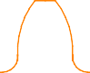
Pressure angle | Constant thought the engagement. | Varies from commencement to end
Ease of manufacture | Involute tooth profile consists of a single (involute) curve and the track cutter used for regenerating the profile has straight teeth. The rack cutter is cheaper and the method of manufacture is simpler. This leads to reduction in the cost of manufacture of involute teeth. | The cycloidal tooth profile consists of two curves (epicyloid and hypocycloid). The method of manufacture is more involved and leads to costlier gear tooth.
Centre distance | Perhaps the most desirable feature of involute teeth is that a small variation in centre distance does not change the velocity ratio. Thus, distance between shafts need not necessarily be maintained exact as per design specifications. This gives great flexibility during assembly and larger tolerances may be permitted. | Exact centre distance is necessary to transmit constant velocity ratio.
Interference | Since involute curve doesn’t exist within base circle, interference is always possible if base circle radius is larger than dedendum circle radius. | Since outside the pitch (directing) circle epicycloidal curve exists and inside it the hypocycloidal curve exists, cycloidal curve can exist everywhere on tooth profile and no interference exists.
Strength | The radius of curvature of involute curve, near the base circle, is quite  small and contact stresses are likely to | Cycloidal curve (hypocycloidal in particular) produces a  spreading flank and, for this

 | be very high. The tooth profile in flank portion is almost radial. Both the factors together produce a tooth weaker in flank region compared to cycloidal tooth. | reason, cycloidal tooth is stronger
Wear | In involute tooth profile gears, convex surface of pinion tooth comes in contact with convex portion of gear tooth and this leads to more wear. | In cycloidal tooth profile epicycloidal shape of face of gear tooth comes in contact with hypocloidal flank portion of pinion tooth. Thus, a convex flank has a contact with concave face which results in lesser wear.
Running | Being the angle made by common tangent of base circles with common tangent to pitch circles at pitch point, the pressure angle remains constant throughout the engagement. This ensures smooth running of the gears. | Pressure angle varies continuously; being zero at the pitch point and maximum at the point of engagement and disengagement. This causes continuous variation in power component and in bearing load. The running is less smooth
Basic form | Constant for all gears | Variable depending upon gear ratio
Path of contact | Straight line | Curve

Path of contact:
It is the locus of point of contact of two mating teeth from the beginning of the engagement to the end of the engagement.
Path of approach: It is the portion of path of contact from the beginning of the engagement to the pitch point.
Path of recess: It is the portion of path of contact from pitch point to the end of engagement.

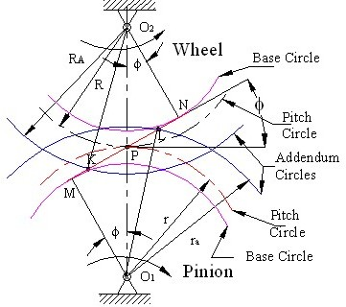

As shown in the fig. MN is the common tangent at to the base circle. It is equal to the common normal at the point of contact of two teeth. The addendum circle cuts the common tangent MN at point K & L. In other words, contact of teeth begins at K and ends at L.
Let, O2P = Pitch circle radius of gear = R O2K = Addendum circle radius of gear = RA
O2N = Base circle radius of gear = O2P cosφ= R cosφ
O1P = Pitch circle radius of pinion = r
O1L = Addendum circle radius of pinion = rA
O1M = Base circle radius of pinion = O1P cosφ= r cosφ
φ = Pressure angle
Length of path of contact =KL = KP + PL (1)
Where, KP = Path of approach PL = Path of recess
Path of approach = KP = KN – PN (2)
From triangle O2PN,
PN = O2P sin = R sinφ
Join O2 to K and from triangle O2KN,
R − (
2 2
A
R cos  )
2
KN = =
O K 2 − O N 2
2
2
Substituting the values of PN & KN in equation (2)

Path of approach
(3)
− R sin ............
2
A
2
2
2
1
R − R cos  )
KP = (
Path of recess = PL = ML – MP (4)

From triangle O1MP,
PM = O1P sinφ = r sinφ
Join O1 to L and from triangle O2ML,
r − (
2
r cos  )
2
2
A
ML = =
O L2 − O M 2
1
1
Substituting the values of MP & ML in equation (4)

Path of recess
(5)
− r sin ............
2
A
2
2
2
1
r − r cos  )
PL = (
Substituting the values of EP & PF in equation (1), we get

Path of contact
(6)
2
A
2
A
2
2 2
2
1
r − r cos  ) − (R + r )sin ............
2
2
1
R − R cos  ) + (
KL = (
If the driver & driven have equal number of teeth, then the diameter of the driver & driven gears are same. Therefore, for equal gears, the equation (6) becomes,
(7)
⎦
⎥
A
⎣
⎤
2
2
2
2
1
R − R cos  ) − R sin ............
⎢
⎡
KL = 2 (

Arc of contact:
It is the locus of point on the pitch circle of two mating teeth from the beginning of the engagement to the end of the engagement. In Figure, the arc of contact is EPF or GPH.
Arc of approach: It is the portion of arc of contact from the beginning of the engagement to the pitch point.
Arc of recess: It is the portion of arc of contact from pitch point to the end of engagement.

Arc of contact = length of path of contact/ cos …… (8)
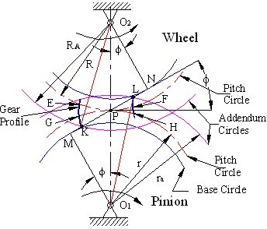

Contact ratio (C.R.): Ratio of angle of action to the pitch angle OR Average number of pairs of teeth which are in contact.

CR = 


=  + 



Length of path of contact
= ---------------------------------------
Base pitch Length of path of contact
= ---------------------------------------
π m cosφ Length of arc of contact
= ---------------------------------------
π m
Length of arc of contact
= ---------------------------------------
Circular pitch

Interference:
The phenomenon when the tip of tooth undercuts the root of its mating gear is known as interference OR contact of portion of the two tooth profiles which are not conjugate is called interference.

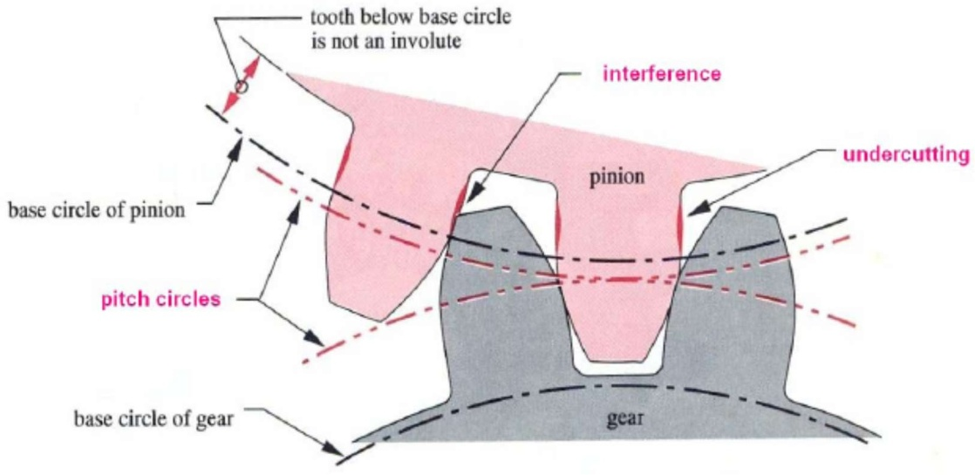

- If the radius of the addendum circle of the pinion is increased to O1N, the point of contact L will move
- When the axis is further increased, the point of contact L will be on the inside of the base circle of the wheel & not on the involute profile of the tooth on the wheel.
- Similarly, if the radius of the addendum circle of the wheel increases beyond the O2M, then the tip of the tooth on the wheel will cause interference with the pinion
- Points M & N are called interference points

Methods to avoid interference & its effects
- Under cutting: Undercutting the flank of pinion teeth, leads to a weakening of the tooth and complication of manufacturing.
- Increasing the centre distance: With this correct tooth action is maintained, but the pressure angle is increased, leading to higher tooth pressure and increased backlash.
- By tooth correction: With this centre distance and base circle remain unaltered, but thickness of the gear tooth at the pitch circle becomes greater than P/2 and that of pinion becomes less than P/2.
- Height of the teeth may be reduced

Minimum number of teeth required to avoid interference:
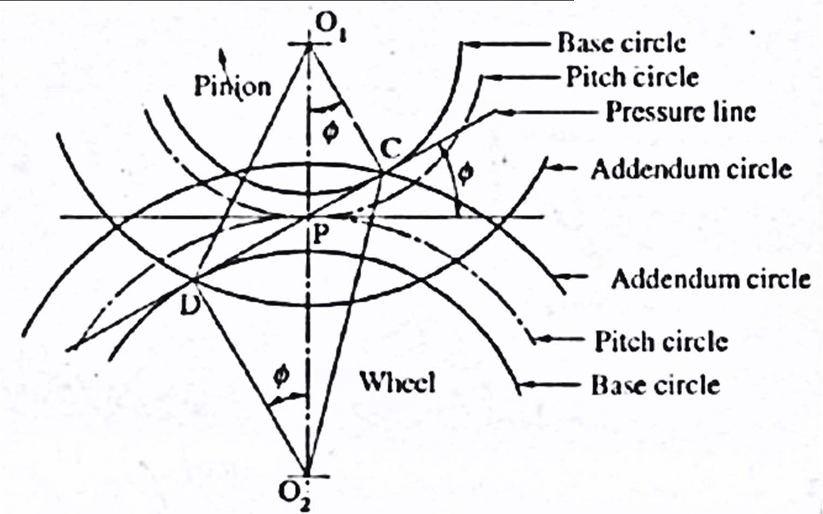

  - Pinion turns counter-clockwise & drives the gear
  - CD = common tangent
  - C & D interference points
  - If the path of contact does not extend beyond either of these points, interference is avoided
  - O1D = limiting value of addendum circle radius of pinion
O2C = limiting value of addendum circle radius of gear
  - Each addendum circle radius is compared with its limiting value to determine whether there will be a interference
  - Interference likely to occur on pinion than on gear, and in this case, the critical radius is O2C, which limits the number of teeth on pinion
O1P = pitch circle radius of pinion = r = mt/2 O2P = pitch circle radius of gear = R = mT/2 O2D = Base circle radius of gear = Rb
O2C = addendum circle radius of gear = Ra T = Number of teeth on gear
t = Number of teeth on pinion aw = addendum constant of gear
ap = addendum constant of pinion awm = addendum of gear
apm = addendum of pinion G = gear ratio = T/t
From the right-angle triangle O2CD,
O2C² = O2D² + CD² = O2D² + (CP+PD)²
= O2D² + (O1P sinφ+ 02P sinφ)² Ra2 = Rb2 + (r sinφ+ R sinφ)²
= (R cosφ)2 + (r + R)2 sin2 φ
= R2 cos2 φ + r2 sin2 φ + R2 sin2 φ + 2 r R sin2 φ
= R2 (cos2 φ + sin2φ) + r2 sin2φ + 2 r R sin2φ
= R2 + r2 sin2 φ + 2 r R sin2φ
R = R2 + r 2 sin2  + 2Rr sin2  (1)
a
Minimum number of teeth, We know that,
R 2 = R2 + r 2 sin 2  + 2rR sin 2 
a

= 2 ⎡ r 2 2
⎣

2r 2 ⎤

R ⎢1+ R2 sin
 + sin 
R ⎦

= 2 ⎡ r 2 ⎛ r ⎞⎤
⎥
R ⎢1+ R sin ⎜ R + 2⎟⎥(2)
⎣ ⎝ ⎠⎦

GEAR RATIO = N1/N2 = R/r = T/t

2 2 ⎡
sin 2  ⎛ 1 ⎞⎤

Ra = R ⎢1 + G ⎜ G + 2⎟⎥

⎣ ⎝
⎡ sin 2  ⎛ 1
⎠⎦
1
⎞⎤ 2

Ra = R⎢1 + G ⎜ G + 2⎟⎥
.....................(3)

⎣ ⎝ ⎠⎦
 Addendum of Gear = a2 = awm = RA -R

⎡ sin 2  ⎛ 1
1
⎞⎤ 2

awm = R⎢1+
G ⎜ G + 2⎟⎥ − R

⎛
= ⎜ ⎡
⎣ ⎝
sin 2  ⎛ 1

⎠⎦
1 ⎞
⎞⎤ 2 ⎟

R⎜ ⎢1+ G ⎜ G + 2⎟⎥
−1⎟

⎜ ⎣ ⎝
⎝
⎛
⎠⎦ ⎟
⎠
1 ⎞

= mT ⎜ ⎡ sin 2  ⎛ 1

⎞⎤ 2 ⎟

2 ⎜ ⎢1+ G ⎜ G + 2⎟⎥
−1⎟

⎜ ⎣ ⎝
⎝
⎛
⎠⎦ ⎟
⎠
1 ⎞

T ⎜ ⎡ sin 2  ⎛ 1
⎞⎤ 2 ⎟

aw = 2 ⎜ ⎢1+ G ⎜ G + 2⎟⎥
−1⎟

⎜ ⎣ ⎝
⎝
⎠⎦ ⎟
⎠

Number of teeth on gear to avoid interference is,
⎠⎠
+ 2⎟⎟ −1
⎝ G
⎜
G
⎝
2
⎞
⎞
⎛ 1
2
1
⎜1+ sin 
⎛
.....................(4)
1
2aw
T =
Number of teeth on the pinion = t = T/G
If number of teeth on the pinion “t” is same as the number of teeth on gear “T”, then the gear ratio G is equal to one.
Then equation (4) becomes,
2
2
.....................(5)
1
1+ 3sin  ) −1
(
2aw
t = T =

Involutometry:
  - Study of the geometry of involute is called involutometry
  - Let B & C be two points on the involute
  - Normal from point B & C are tangent to the base circle Let,
rA = base circle radius
rB= radius of point B on the involute rC= radius of point C on the involute
φB = pressure angle for point B
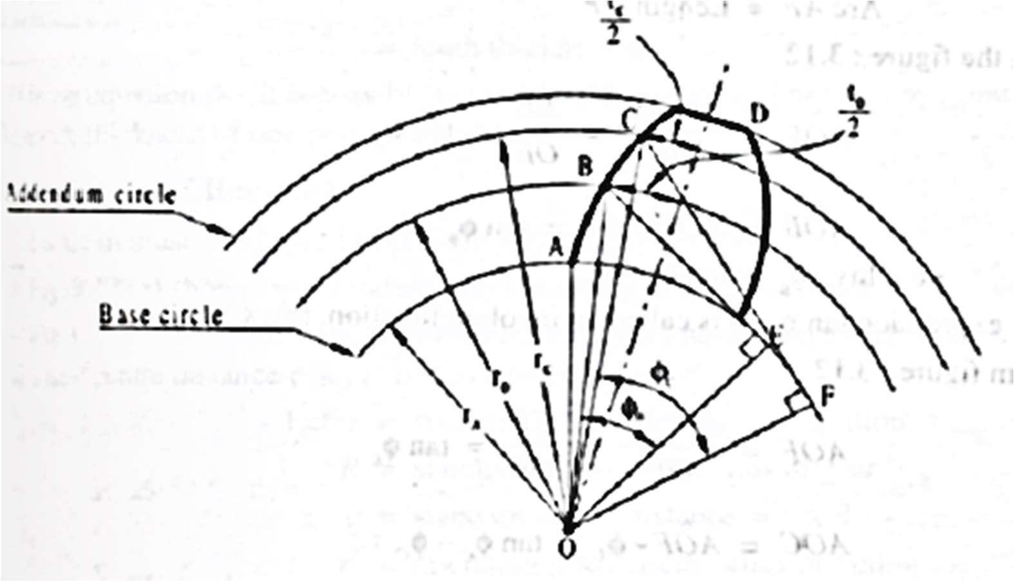
φC = pressure angle for point C tB= arc tooth thickness at B tC= arc tooth thickness at C

From triangle OBE,

cos
= OE = rA

B OB r
B
rA = rB cosB (1)
From triangle OCF,

cos
= OF = rA

C OC r
C
rA = rC cosC (2)

Equating (1) & (2)
rB cosB

= rC cosC (3)

From the Geometry (By the properties of the involute) Arc AE = Length BE
Arc AF = Length CF

Now from fig.,
∠AOE = Arc AE/OE = BE/OE = tanφB
AOˆB = AOˆE − B = tanB − B
Inv.B = tanB − B (4)

Now from fig,
∠AOF = Arc AF/OF = CF/OF = tanφC
AOˆC = AOˆF − C = tanC − C
Inv.C = tanC − C (5)

From fig., for point B,
AOˆD = AOˆB +

tB

2rB

= tan B
Similarly, for point C,
− B
- tB
2rB
.........(6)

AOˆD = AOˆC +
tC

2rC

Equating (6) & (7)
= tan c
- c
- tC
2rC
.........(7)

tanB
− B
- tB
2rB
= tan c
− c
- tC
2rC

Inv.B
- tB
2rB
= Inv.C
- tC
2rC

tC
2rC
= Inv.B
- Inv.C
- tB
2rB

t = ⎡Inv.
  - Inv.
+ tB ⎤2r (8)

C ⎢ B C 2r ⎥ C
⎣ B ⎦
= tooth thickness at “C”
Using the above equation, it is possible to calculate the tooth thickness at any point on the involute, if the thickness of one point is known.

Backlash:
- It is the difference between the thickness of the tooth & the width of the tooth space in which it meshes.
- Backlash must be allowed to prevent jamming of the teeth
Back lash = space width – tooth thickness
- Fig (a) = two standard gears meshing at centre distance “c”
- Fig (b) = condition after two gears have been pulled apart at a distance Δc to give a new centre distance c’
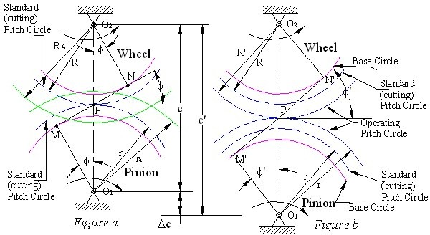
Let,
P’ be the new pitch point
r = standard pitch circle radius of pinion R= standard pitch circle radius of gear
c = standard centre distance = R + r
r’ = operating pitch circle radius of pinion R’ = operating pitch circle radius of gear c' = operating centre distance = R’ + r’
φ= standard pressure angle
φ’= operating pressure angle
h = tooth thickness of pinion on standard pitch circle = p/2 h’ = tooth thickness of pinion on operating pitch circle
H = tooth thickness of gear on standard pitch circle
H’ = tooth thickness of gear on operating pitch circle

p = standard circular pitch =
2r = 2R

t T
p’ = operating circular pitch = 2r' = 2R'

t T

Δc = change in centre distance B = backlash
T = number of teeth on gear t = number of teeth on pinion
We know,
r = R = c r' R' c'
c'cos ' = c cos
∴c' = c cos

cos'
Now,
Δc = c'−c = c cos − c = c⎡ cos − ⎤
⎣
⎦

cos' ⎢cos ' 1⎥
On the operating pitch circle,
Operating pitch = sum of the tooth thickness + backlash i.e. p’ = h’ + H’ + B (1)
By involutometry,

h' = 2r' ⎡ h
⎢
⎣ 2r
- inv − inv ⎤
⎦
'⎥

H ' = 2R' ⎡ h
⎢
⎣ 2R
- inv − inv'⎤
⎦
⎥

Substituting The values of H’ & h’ inn equation (1),

p' = 2r' ⎡ h
+ inv. − inv. ⎤ + 2R' ⎡ h + inv. − inv. ⎤ + B

⎢⎣ 2r
' ⎢⎣ 2R '

p' = h⎛ r' + R' ⎞ + 2inv.(r'+R')− 2inv. '(r'+R')+ B
⎥
⎥
⎦
⎦

⎜ ⎟
⎝ ⎠
r
R
p' = h⎛ c' + c' ⎞ + 2c'inv. − 2c'inv.'+B

⎜ ⎟
⎝ ⎠
c
c
∴ B = p'−2h c' + 2c'[inv. '−inv. ]

c
= 2r' − 2 2r × c' + 2c'[inv.'−inv. ]

t 2t c
= 2 ⎡r'−r c'⎤ + 2c'[inv.'−inv. ]
t ⎢⎣ c ⎥⎦
= 2 ⎡r'−r r'⎤ + 2c'[inv.'−inv. ]
t ⎢⎣ r ⎥⎦
= 2c'[inv.'−inv. ]
Baklash = B = 2c'[inv. '−inv. ]

